Test Case: tc001_SPX_Dev5_Crear_Solicitud_Articulo_Almacen
Step 1 - Enter username and password and click to button Enter : Credentials Entered
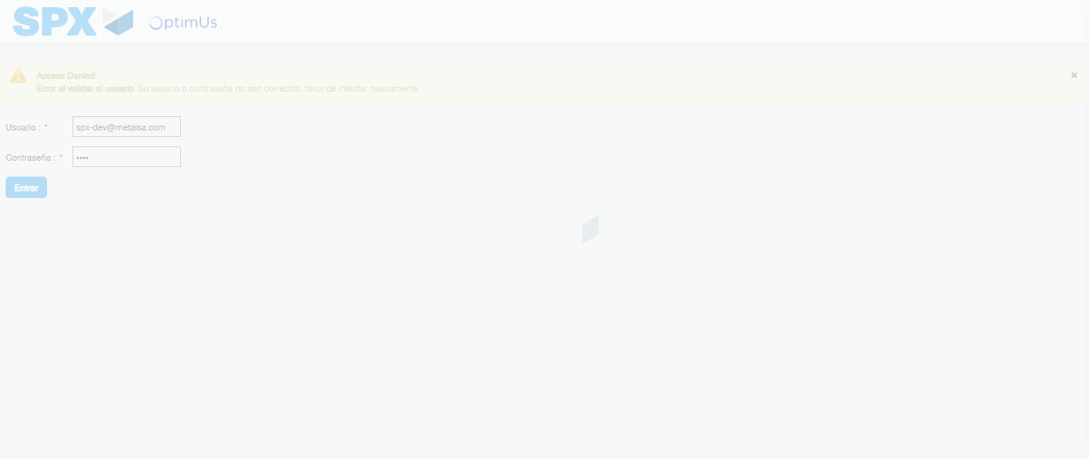Image file-name: QC_Testing-tc001_SPX_Dev5_Crear_Solicitud_Articulo_Almacen-1787939350061

Step 2 - Select to UEN and Access to Request for a New Inventory Item : UEN Correctly selected and Correct access
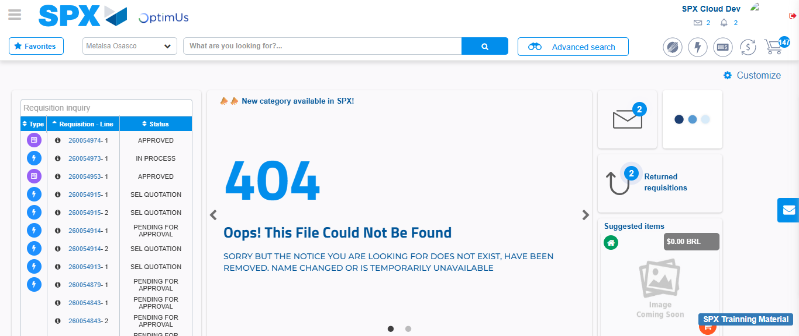Image file-name: QC_Testing-tc001_SPX_Dev5_Crear_Solicitud_Articulo_Almacen-1787939380356

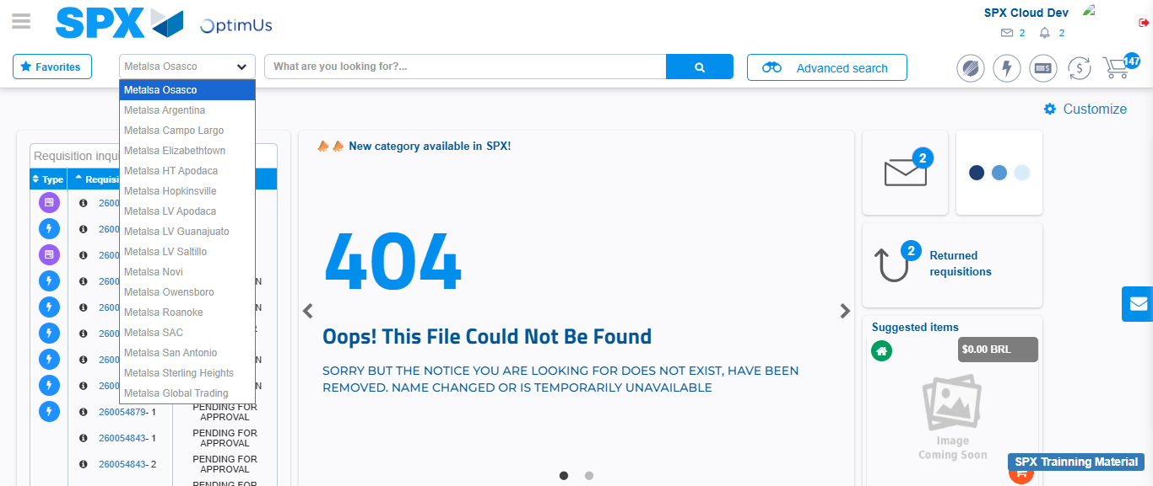Image file-name: QC_Testing-tc001_SPX_Dev5_Crear_Solicitud_Articulo_Almacen-1787939380821

Image file-name: QC_Testing-tc001_SPX_Dev5_Crear_Solicitud_Articulo_Almacen-1787939399955

Step 3 - Select options first section : Options seleted correctly
Image file-name: QC_Testing-tc001_SPX_Dev5_Crear_Solicitud_Articulo_Almacen-1787939400203

Image file-name: QC_Testing-tc001_SPX_Dev5_Crear_Solicitud_Articulo_Almacen-1787939400370

Step 4 - Select options at Screen: Options seleted correctly
Image file-name: QC_Testing-tc001_SPX_Dev5_Crear_Solicitud_Articulo_Almacen-1787939400203

Image file-name: QC_Testing-tc001_SPX_Dev5_Crear_Solicitud_Articulo_Almacen-1787939400370

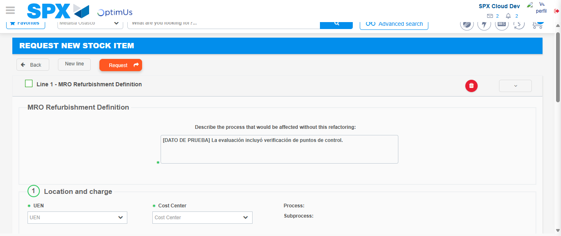Image file-name: QC_Testing-tc001_SPX_Dev5_Crear_Solicitud_Articulo_Almacen-1787939410926

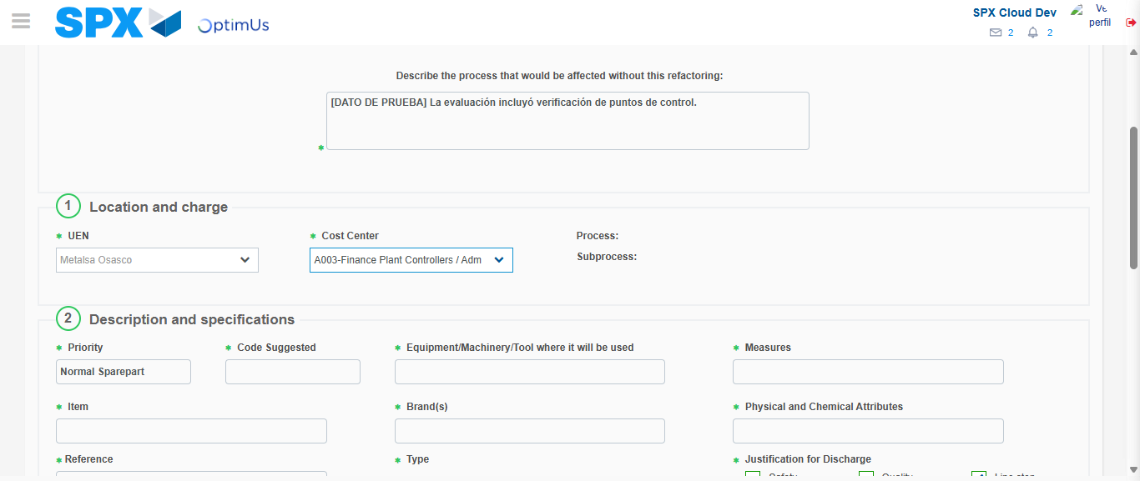Image file-name: QC_Testing-tc001_SPX_Dev5_Crear_Solicitud_Articulo_Almacen-1787939413273

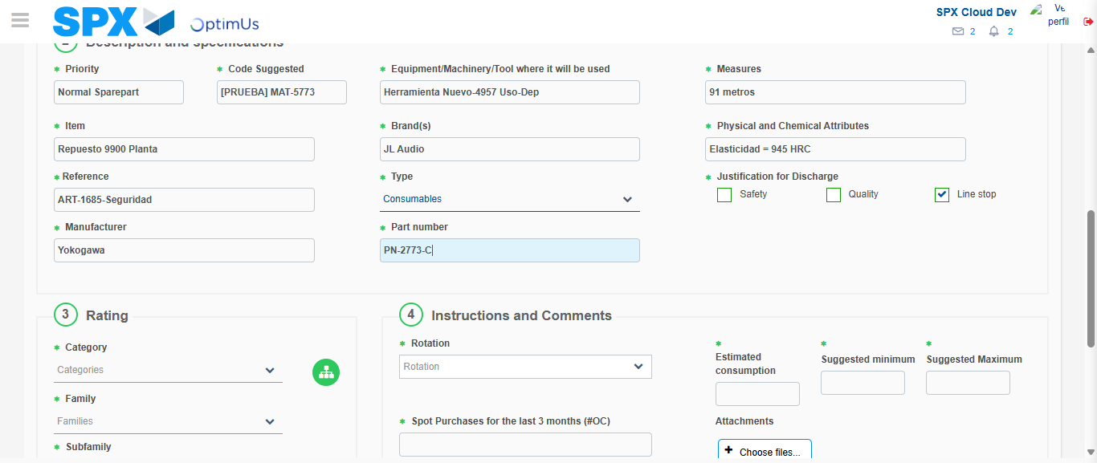Image file-name: QC_Testing-tc001_SPX_Dev5_Crear_Solicitud_Articulo_Almacen-1787939414472

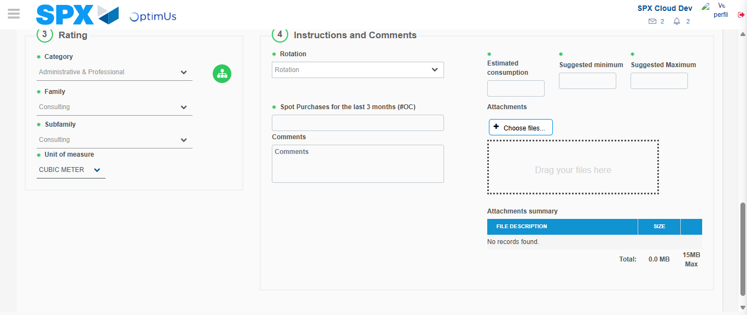Image file-name: QC_Testing-tc001_SPX_Dev5_Crear_Solicitud_Articulo_Almacen-1787939418587

Step 5 - Request New Item : Request Accepted
Image file-name: QC_Testing-tc001_SPX_Dev5_Crear_Solicitud_Articulo_Almacen-1787939380356

Image file-name: QC_Testing-tc001_SPX_Dev5_Crear_Solicitud_Articulo_Almacen-1787939380821

Image file-name: QC_Testing-tc001_SPX_Dev5_Crear_Solicitud_Articulo_Almacen-1787939399955

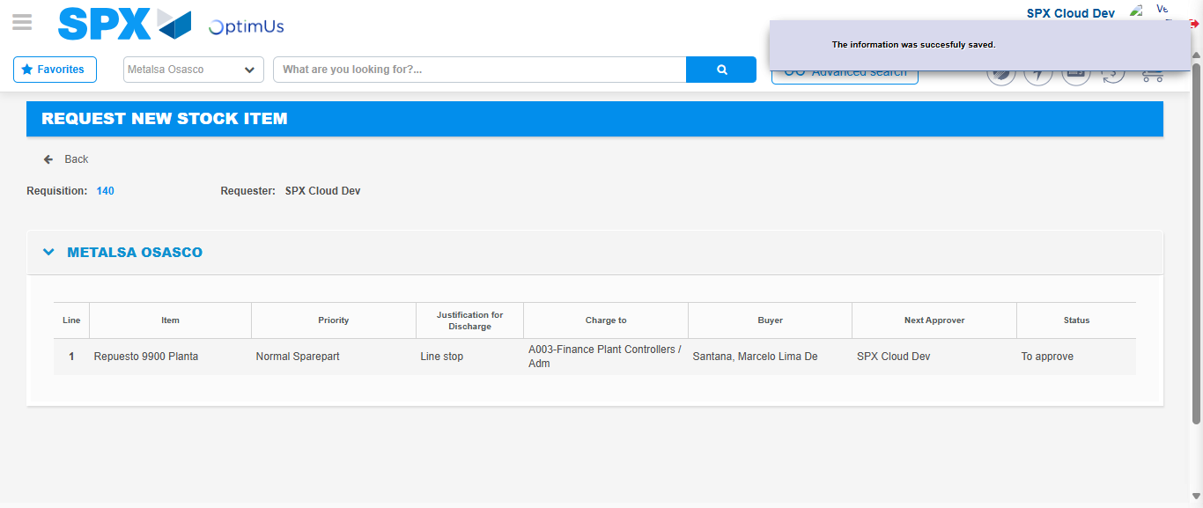Image file-name: QC_Testing-tc001_SPX_Dev5_Crear_Solicitud_Articulo_Almacen-1787939425119

Image file-name: QC_Testing-tc001_SPX_Dev5_Crear_Solicitud_Articulo_Almacen-1787939425293

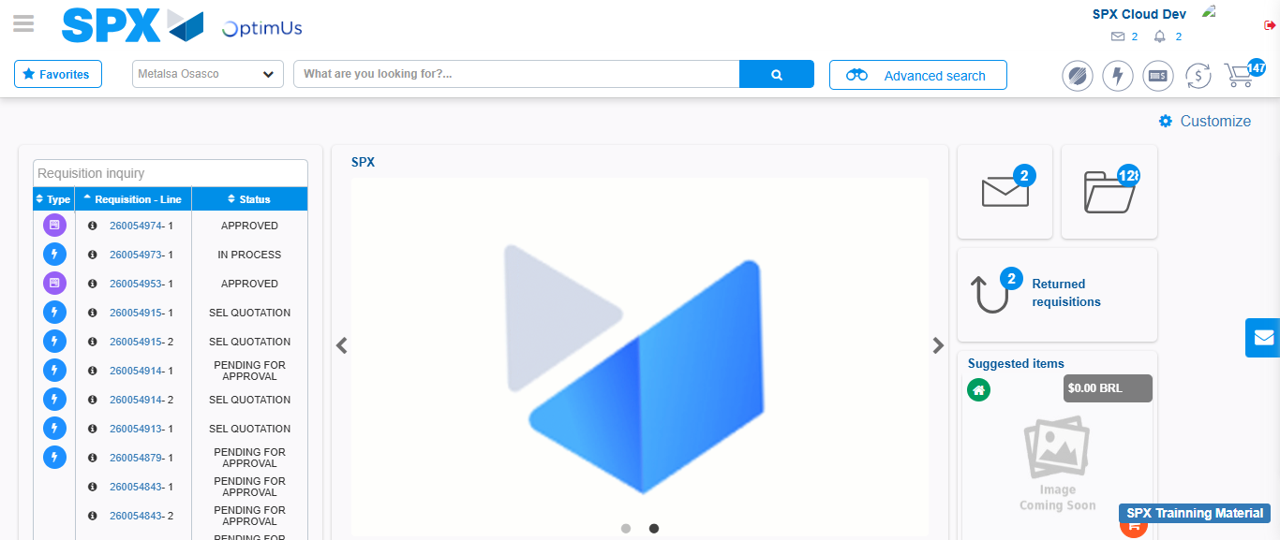Image file-name: QC_Testing-tc001_SPX_Dev5_Crear_Solicitud_Articulo_Almacen-1787939447517

Step 7 - Return to Main Page SPX : Return to Main Page SPX
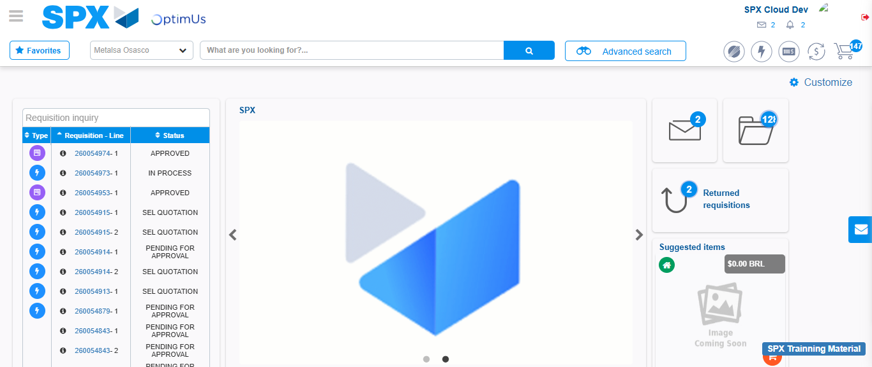Image file-name: QC_Testing-tc001_SPX_Dev5_Crear_Solicitud_Articulo_Almacen-1787939447771

